**LINEAR REGRESSION**: Homework 

*Professor Jingchen Liu*

Fan Yang

UNI: fy2232

# Problem 1

## (a)

Suppose  and .

Then the  element in  is 

So



While





which means the  element in covariance matrix of Y equals to that of 

So, covariance matrix of Y = .

# Problem 2



As we know  follows *N* (0, 1) distribution;

and  follows .

When we use ,  follows  distribution;

and  follows .

Therefore,  follows a *F* distribution *F* (1, n-2). So *t*-test and *F*-test are equivalent in the sense that the .

# Problem 3 (6.5)

## (a)

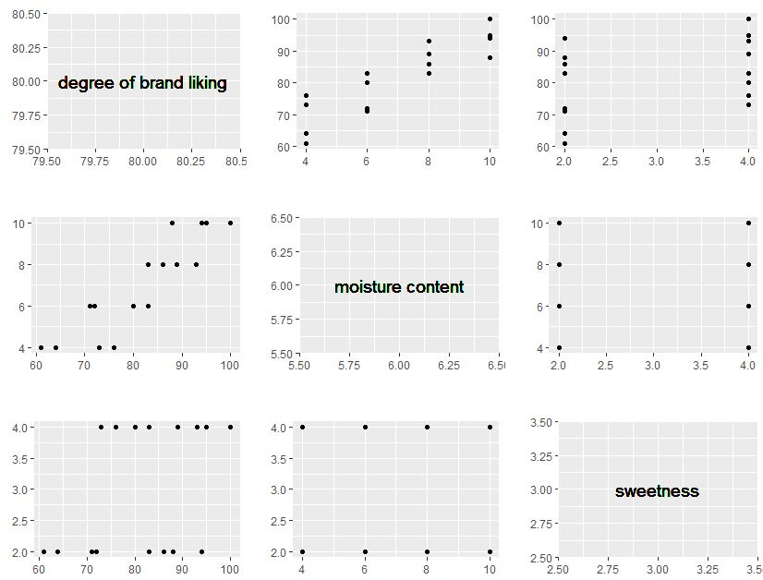



From the graphs above, we conclude that  and  are uncorrelated.  and  represent a likely linear relation while  seems to have weak relation with .

## (b)





## (c)



We can see the boxplot of residuals below. The median of residuals lays nearly to the mean of residuals which is 0, and the plot shows a strong symmetric property. Most of the values lay between -2 and 2 which is a small variation.

Therefore, our models seems to be a good fit from the point of residuals.

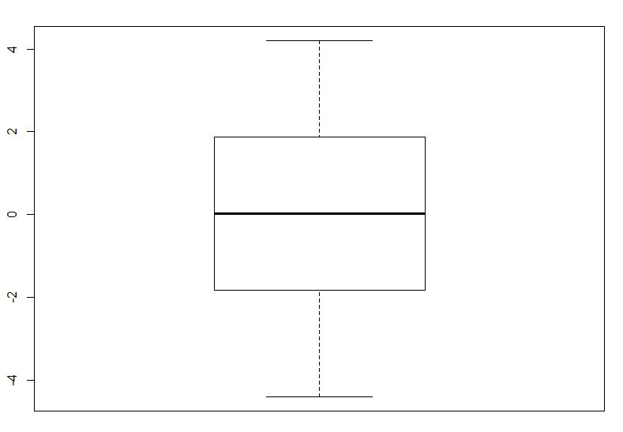

## (f)

Hypothesis:



if , then conclude 

if , then conclude 



Now , so we conclude  that the regression function is linear.

# Problem 4 (6.7)

## (a)



We get the , which means there are about 95.21% of total variation can be explained by our model.

## (b)



We get the coefficient of simple determination , and this is different from the  in part (a).

# Problem 5 (6.8)

## (a)



The interval estimate is 

## (b)



The prediction interval is .

# Problem 6 (6.25)

Suppose the original data is

  

Since we know that , we can make the following transform:

  

Then we only need to fit the model .